CHAROTAR UNIVERSITY OF SCIENCE & TECHNOLOGY
Seventh Semester of B. Tech (IT) Examination
December 2014
IT408 Service Oriented Architecture
Date: 05.12.2014, Friday Time: 10.00 a.m. To 01.00 p.m. Maximum Marks: 70
Instructions:
- The question paper comprises two sections.
- Section I and II must be attempted in separate answer sheets.
- Make suitable assumptions and draw neat figures wherever required.
- Use of scientific calculator is allowed.

SECTION – I
Q - 1 | Answer the question below. | [07]
 | What is Service Oriented Architecture?
 | What is role of WSDL in web service Technology?
 | BPEL4WS is used for ___________and its full-form is ____________.
 | What is UDDI in web service technology?
 | Write benefits of REST Web service.
 | Describe fault element of SOAP.
 | Explain OWL and how it differs from RDF?
Q – 2.a | Compare Object Oriented Computing with Service Oriented Computing. | [04]
Q – 2.b | Answer any two: | [10]
 | Explain any five elements of SOAP format with Example.
 | Write WSDL for web service which adds two integers and returns integer.
 | Explain Model Driven Architecture.
Q – 3.a | Explain Enterprise Perspective of SOA which covers eight different aspects of service within an enterprise with Figure.  OR | [07]
Q – 3.a | What are the Similarities between EA and SOA architecture? Describe relationship between EA and SOA with figure. | [07]
Q – 3.b | Explain conceptual contents of SOA Reference Architecture with figure. | [07]
 | OR
Q – 3.b | List Service characteristics and Discuss how these characteristics can be achieved using Web Service and SOA. | [07]
SECTION – II
Q – 4 | Answer the question below. | [07]
 | Write benefit of Xml schema over DTD.
 | Service dimensions are ______ , ______, ______ and _______.
 | Justify: SOA is loosely coupled architecture.
 | Give difference between atomic and business process.
 | True/False: Service operations are stateless.
 | What is service granularity?
 | Differentiate between Service Broker and Service Provider.
Q – 5.a | Answer any two. | [10]
 | Write short note on Integrations vs. Interoperation.
Explain motivation for RDF and following terms of RDF:
- Resources | - Literals
- Properties | - Statements

 | Give example of OWL and explain How inference works in OWL.
Q – 5.b | Discuss ACID properties in terms of SOA. | [04]
 | OR
Q – 5.b | Describe and compare faultHandler and compansationHandler BPEL4WS. | [04]
Q – 6.a | Write a short on Orchestration Vs. Choreography | [04]
 | OR
Q – 6.a | Explain following Architectural elements of SOA:  - Enterprise Resources - Integration Services  - Business Services - Business Processes | [04]

Q – 6.b | Student result is saved in XML file as shown below. Write XSLT/ Xml style sheet to show result in tabular format.  <student id=”11IT001’>  <subject code=”111’>77</subject>  <subject code=”112’>59</subject>  <subject code=”113’>63</subject>  </student>  <student id=”11IT002’> . . .</student>  . . .  <student id=”11IT060’> . . .</student> | [05]
Q – 6.c | Write XML and DTD for Exam timetable as shown in figure 1. | [05]
 | OR
Q – 6.c | Write XML and XML Schema for Exam timetable as shown in figure 1.  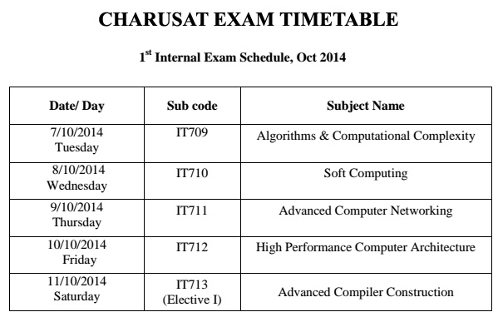  Figure 1: Exam Time table | [05]
***

